**NLP**

Probability and Bayes’ Rule

To calculate a probability of a certain event happening, you take the count of that specific event and you divide by the sum of all events. Furthermore, the sum of all probabilities has to equal 1.

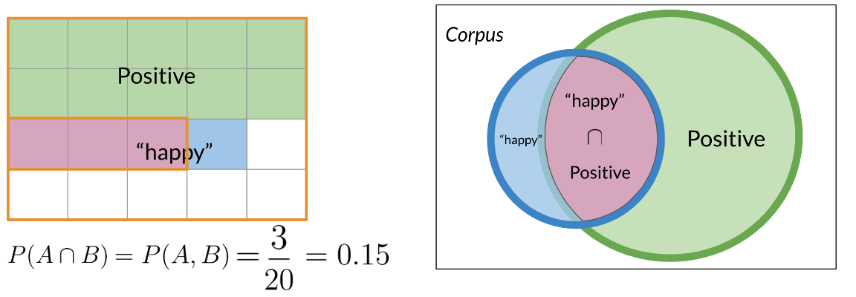

To compute the probability of 2 events happening, like "happy" and "positive" in the picture above, you would be looking at the intersection, or overlap of events. In this case red and blue boxes overlap in 3 boxes. So the answer is \frac{3}{20}203​.

Bayes' Rule

Note that we multiplied by P(positive) to make sure we don't change anything. That concludes Bayes Rule which is defined as

P(X|Y) = \frac{P(Y|X) P(X)}{P(Y)} *P*(*X*∣*Y*)=*P*(*Y*)*P*(*Y*∣*X*)*P*(*X*)​.

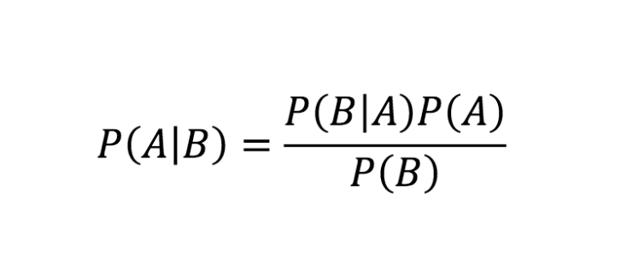

# Naïve Bayes Introduction

# We call it naïve because we make a naïve assumption that features are independent of each other, but in reality it rare

# But it works great for sentimental analysis

# Step 1- sum of positive and negative works

# https://d3c33hcgiwev3.cloudfront.net/imageAssetProxy.v1/fwihrJk_RSGIoayZPxUhTQ_3cd35492d526492dbcae2e4baa02bdf4_Screen-Shot-2020-09-08-at-3.38.05-PM.png?expiry=1632009600000&hmac=p8xomRy-aN1Tc5AragucCyL2XqWA13ReSe7KQdEUH6013*

# Step 2 – we find probability of the each word

# https://d3c33hcgiwev3.cloudfront.net/imageAssetProxy.v1/Iiek1X0pSX6npNV9KXl-NQ_2945fa3844184948b0a2590d0683b4f8_Screen-Shot-2020-09-08-at-3.41.46-PM.png?expiry=1632009600000&hmac=Fuh6oLeyhQT7vRpbmYLJxE1z1LqcujFcZWQ3ZdgmWJg

# Step 3- we find the likelihood score

# https://d3c33hcgiwev3.cloudfront.net/imageAssetProxy.v1/nc3XUyPHSgyN11Mjx7oMNQ_d2a00c93d29b497bba81a3944072feb9_Screen-Shot-2020-09-08-at-3.43.07-PM.png?expiry=1632009600000&hmac=sfH5x8M_Nu5t4io6hMIO8nRVUQB9gkwGupqjO_yYJEA

# Laplacian Smoothing

# 

# Log Likelihood

To do inference, you can compute the following:

\frac{P(p o s)}{P(n e g)} \prod_{i=1}^{m} \frac{P\left(w_{i} \mid p o s\right)}{P\left(w_{i} \mid n e g\right)} >1 *P*(*neg*)*P*(*pos*)​∏*i*=1*m*​*P*(*wi*​∣*neg*)*P*(*wi*​∣*pos*)​>1

As m*m* gets larger, we can get numerical flow issues, so we introduce the \loglog, which gives you the following equation:

# \log \left(\frac{P(p o s)}{P(n e g)} \prod_{i=1}^{n} \frac{P\left(w_{i} \mid p o s\right)}{P\left(w_{i} \mid n e g\right)}\right) \Rightarrow \log \frac{P(p o s)}{P(n e g)}+\sum_{i=1}^{n} \log \frac{P\left(w_{i} \mid p o s\right)}{P\left(w_{i} \mid n e g\right)} log(*P*(*neg*)*P*(*pos*)​∏*i*=1*n*​*P*(*wi*​∣*neg*)*P*(*wi*​∣*pos*)​)⇒log*P*(*neg*)*P*(*pos*)​+∑*i*=1*n*​log*P*(*wi*​∣*neg*)*P*(*wi*​∣*pos*)​

# https://d3c33hcgiwev3.cloudfront.net/imageAssetProxy.v1/I1jOUPkpSRmYzlD5KSkZUg_8d00fbc64ac94b9a9d9c41d367288447_Screen-Shot-2020-09-08-at-4.10.13-PM.png?expiry=1632096000000&hmac=ovb9SwgOWhzhkpDxyxtjd9VCLLJKULBAKVtNke7nq_A

# Once you computed the \lambda*λ* dictionary, it becomes straightforward to do inference:

# https://d3c33hcgiwev3.cloudfront.net/imageAssetProxy.v1/lqWbkNaCS5alm5DWgvuWoQ_2d4cdfc82bf142f08b89cb49f2908ef8_Screen-Shot-2020-09-08-at-4.17.43-PM.png?expiry=1632096000000&hmac=Ty0aAJNVTGYH6ghItf8A52aesF0ORyKpFkpQUgl6h0A

# Training naïve Bayes

o train your naïve Bayes classifier, you have to perform the following steps:

### **1) Get or annotate a dataset with positive and negative tweets**

### **2) Preprocess the tweets: process tweet (tweet) ➞ [w1, w2, w3,]:**

* Lowercase
* Remove punctuation, urls, names
* Remove stop words
* Stemming
* Tokenize sentences

### **3) Compute freq(w, class):**

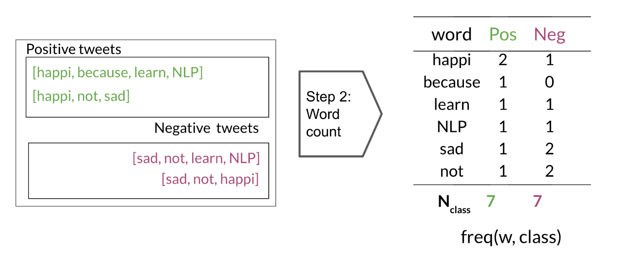

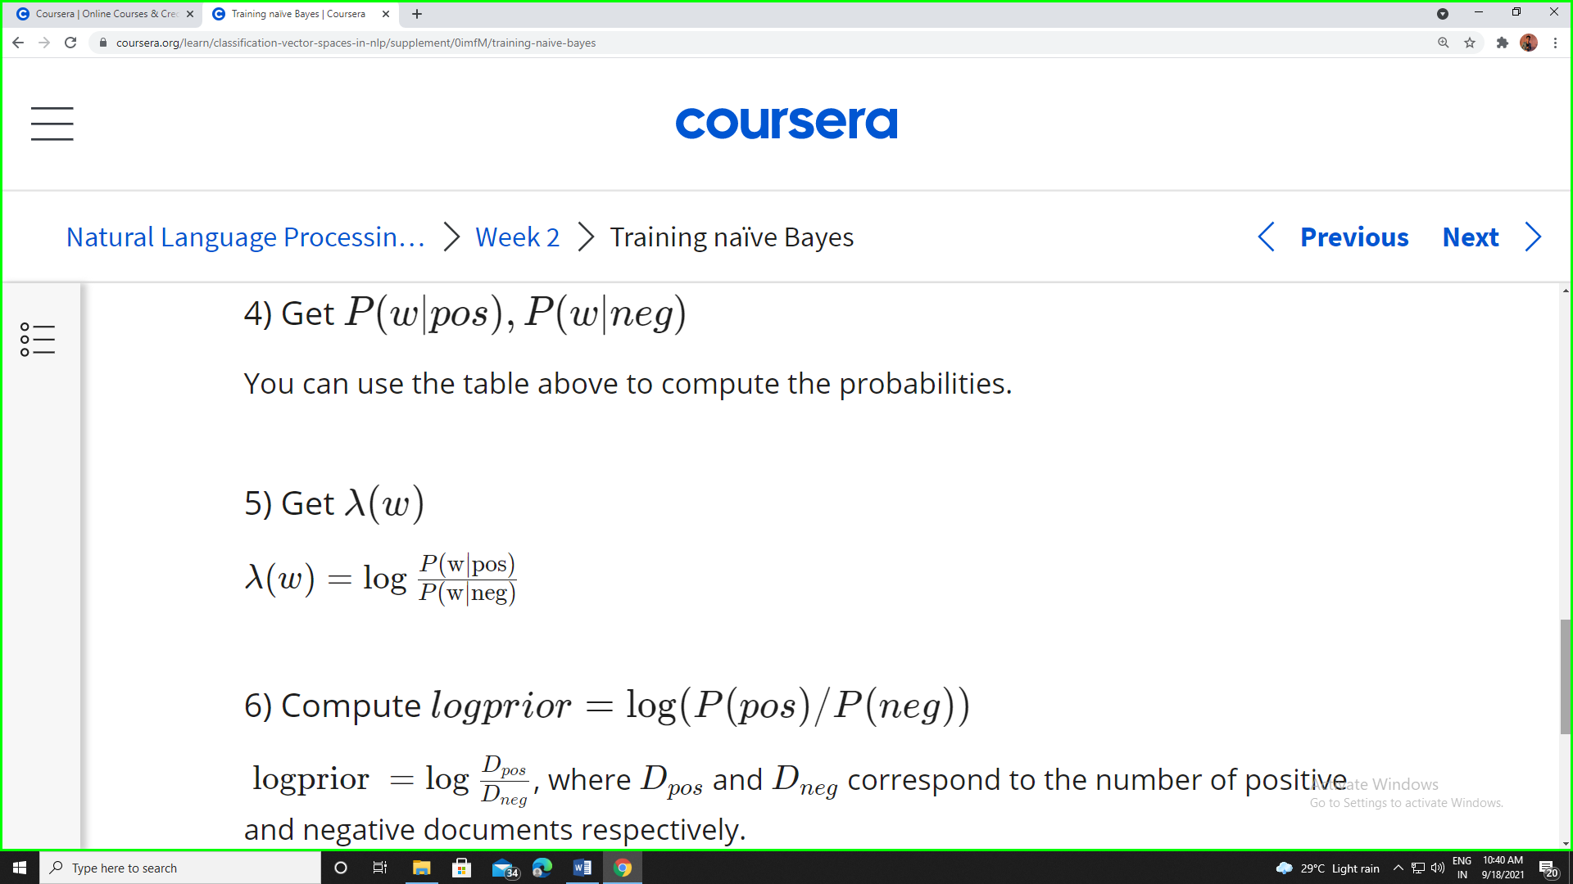

# Testing naïve Bayes

# https://d3c33hcgiwev3.cloudfront.net/imageAssetProxy.v1/DBzYqctbQdSc2KnLW5HURA_3de7717134ec4f3ea36f9318083b60c6_Screen-Shot-2020-09-08-at-4.42.03-PM.png?expiry=1632873600000&hmac=6fQh8uMlt_odf7gJhkUydkJ9lwg93nAaPhiQz3duyTI

# Applications of Naive Bayes

There are many applications of naive Bayes including:

* Author identification
* Spam filtering
* Information retrieval
* Word disambiguation

This method is usually used as a simple baseline. It also really fast.

# Naïve Bayes Assumptions

# https://d3c33hcgiwev3.cloudfront.net/imageAssetProxy.v1/FMyHLVY0SeeMhy1WNMnnFQ_27510d24657b41d99277b77279ec17ff_Screen-Shot-2020-09-16-at-10.42.46-AM.png?expiry=1632873600000&hmac=gDb0vz09GS7f7wRgNQ4wYIj4XXE4uWRIM01tnOlMiXQ

# On Twitter, there are usually more positive tweets than negative ones. However, some "clean" datasets you may find are artificially balanced to have to the same amount of positive and negative tweets. Just keep in mind, that in the real world, the data could be much noisier.

# Naïve Bayes makes the independence assumption and is affected by the word frequencies in the corpus.

# Error Analysis

There are several mistakes that could cause you to misclassify an example or a tweet. For example,

* Removing punctuation
* Removing words
* Adversarial attacks

These include sarcasm, irony, euphemisms